**1.1 Cell Theory**

Four tenets

1. All living things are composed of cells.
2. The cell is the basic functional unit of life.
3. Cells arise only from preexisting cells.
4. Cells contain DNA, and it is passed from parent to daughter cell.

**1.2 Eukaryotic Cells\***

* Can be unicellular or multicellular

Membrane-bound Organelles

1. Nucleus (double-membrane)
   1. Nuclear envelope separates the nuclear environment (DNA transcription) from the cytoplasm (RNA translation)
   2. Contains **nucleolus**, where rRNA is synthesized
2. Mitochondria (double-membrane)
   1. Outer membrane
   2. Inner membrane
      1. Its infoldings = cristae
      2. The space inside = mitochondrial matrix
   3. Intermembrane space
3. Lysosomes
   1. Can ingest substances by endocytosis, and use **hydrolytic enzymes** to break them down
   2. Can release hydrolytic enzymes (autolysis) → **apoptosis**
4. Endoplasmic Reticulum
   1. Rough ER
      1. Contains **ribosomes** (permit the translation of proteins destined for **secretion** directly into its lumen)
   2. Smooth ER
      1. **Lipid synthesis**
      2. **Detoxification** of drugs and poisons
      3. Transports proteins from RER to Golgi Apparatus
5. Golgi Apparatus
   1. Packages, modifies and distributes cellular products → if product is destined for secretion, exocytosis
6. Peroxisomes
   1. Contain **hydrogen peroxide** to break down very long fatty acid chains via **β-oxidation**
   2. Participate in the synthesis of phospholipids
   3. Contain some enzymes in the pentose phosphate pathway

The Cytoskeleton

1. Microfilaments
   1. Made up of **solid** polymerized rods of **actin**
      1. Organized into bundles and networks → resistant to compression and fracture → **protection** for the cell
      2. Can interact with **myosin** to generate ATP for muscle contraction
   2. Participates in **cytokinesis**
      1. During mitosis, cleavage furrow is formed → organize as a ring at the site of division → actin filaments within the ring contract → ring becomes smaller until it pinches off the connection
2. Microtubules
   1. **Hollow** polymers of **tubulin** proteins
      1. Primary pathway along which motor proteins like kinesin and dynein carry vesicles (**cargo transport**)
   2. Motile structures (9+2 structure)
      1. **Cilia**: projections from a cell that are primarily involved in movement of materials along the surface of the cell (e.g. movement of mucus in respiratory tract)
      2. **Flagella**: involved in the movement of the cell itself (e.g. sperm cell through the reproductive tract)
   3. Participates in mitosis
      1. Centrioles migrate to opposite poles → organize the mitotic spindle → microtubules emanating from the **centrioles** attach to the chromosomes via kinetochore → pull sister chromatids apart
3. Intermediate Filaments
   1. Diverse group of **filamentous** proteins e.g. keratin, desmin, vimentin, lamins
   2. Functions
      1. Cell-cell adhesion
      2. Maintenance of overall structural integrity of the cytoskeleton
      3. Make cell structure more rigid
      4. Help anchor other organelles, including nucleus

Tissue Formation

1. Epithelial tissue
   1. Cover the body and line its cavities → **protection** against pathogen invasion
   2. Involved in absorption, secretion, and sensation in certain organs
   3. Constitute the **parenchyma** (functional part) in most organs
      1. Nephrons in the kidney, hepatocytes in the liver, acid-producing cells of the stomach
   4. Classified by number of **layers**
      1. Simple epithelia (one layer of cell)
      2. Stratified epithelia (multiple layers)
      3. Pseudostratified epithelia (looks like multiple layers, but actually only one)
   5. Classified by **shape**
      1. Cuboidal (cube)
      2. Columnar (long and thin)
      3. Squamous (flat and scalelike)
2. Connective tissue
   1. Supports the body and provides a **framework** for the epithelial cells to carry out their functions
   2. E.g. bone, cartilage, tendons, ligaments, adipose tissue, blood
   3. Most cells in connective tissues produce and secrete materials e.g. collagen and elastin → form the extracellular matrix
3. Muscle
4. Nervous tissue

**1.3 Classification and Structure of Prokaryotic Cells**

Prokaryotic Domains

1. Archaea
   1. **Visually similar to bacteria**: single-celled organisms
      1. Lack a nucleus or membrane-bound organelles
      2. Contain a single circular chromosome
      3. Divide by binary fission or budding
   2. Contain genes and several metabolic pathways **similar to eukaryotes**
      1. Associate their DNA with histones
      2. Contain similar RNA polymerases
      3. Start translation with methionine
2. Bacteria
   1. Contain cell membrane and cytoplasm, and some have flagella or fimbriae (similar to cilia)

Classification of Bacteria by Shape

1. Cocci (spherical) e.g. Strep
2. Bacilli (rod-shaped) e.g. *E. coli*
3. Spirilli (spiral-shaped) e.g. *T. pallidum* causes syphilis

Aerobes and Anaerobes

1. Obligate aerobes: need oxygen
2. Obligate anaerobes: cannot have oxygen
3. Facultative anaerobes: use oxygen for aerobic metabolism, but can also switch to anaerobic metabolism
4. Aerotolerant anaerobes: unable to use oxygen for metabolism, but not harmed by its presence

Prokaryotic Cell Structure

1. Cell wall
   1. **Gram-positive** (deep purple stain): thick layer of peptidoglycan + lipoteichoic acid
   2. **Gram-negative** (pink-red counterstain): thin layer of peptidoglycan + outer membrane (phospholipid and lipopolysaccharides)
2. Flagella: long whiplike structure used for propulsion
   1. **Chemotaxis**: ability to move toward or away from a chemical stimulus
   2. The hook connects the filament to the basal body (not 9+2 in eukaryotic flagella)
3. Plasmid: not necessary for survival of the prokaryote, but may confer an advantage e.g. antibiotic resistance

**1.4 Genetics and Growth of Prokaryotic Cells**

Binary Fission

* Simple form of **asexual** reproduction in prokaryotes
* Replication of circular chromosome → cell grows in size → invagination → 2 daughter cells
* Fewer events than mitosis → produce more rapidly e.g. *E. coli*

Genetic Recombination

1. **Transformation**: Integration of foreign genetic material into the host genome
2. **Conjugation**: Mating bridge from donor male **(+)** to recipient female **(-)**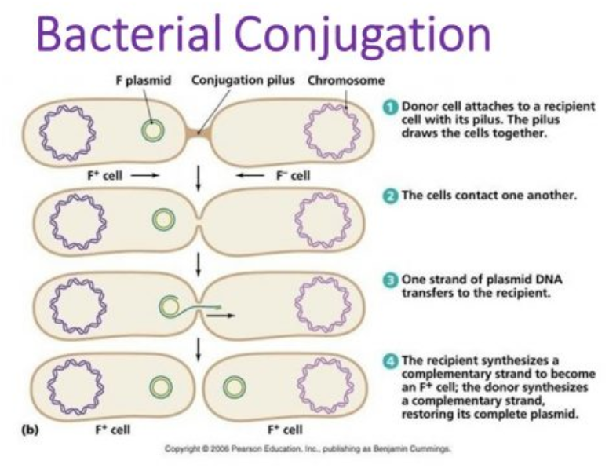
3. **Transduction**: Requires virus vector (i.e. **bacteriophage** during lytic cycle) that accidentally packages and carries genetic info from one bacterium to another
4. **Transposons**: genetic elements capable of inserting and removing themselves from the genome

Growth

* Four phases: Lag, Exponential, Stationary, Death

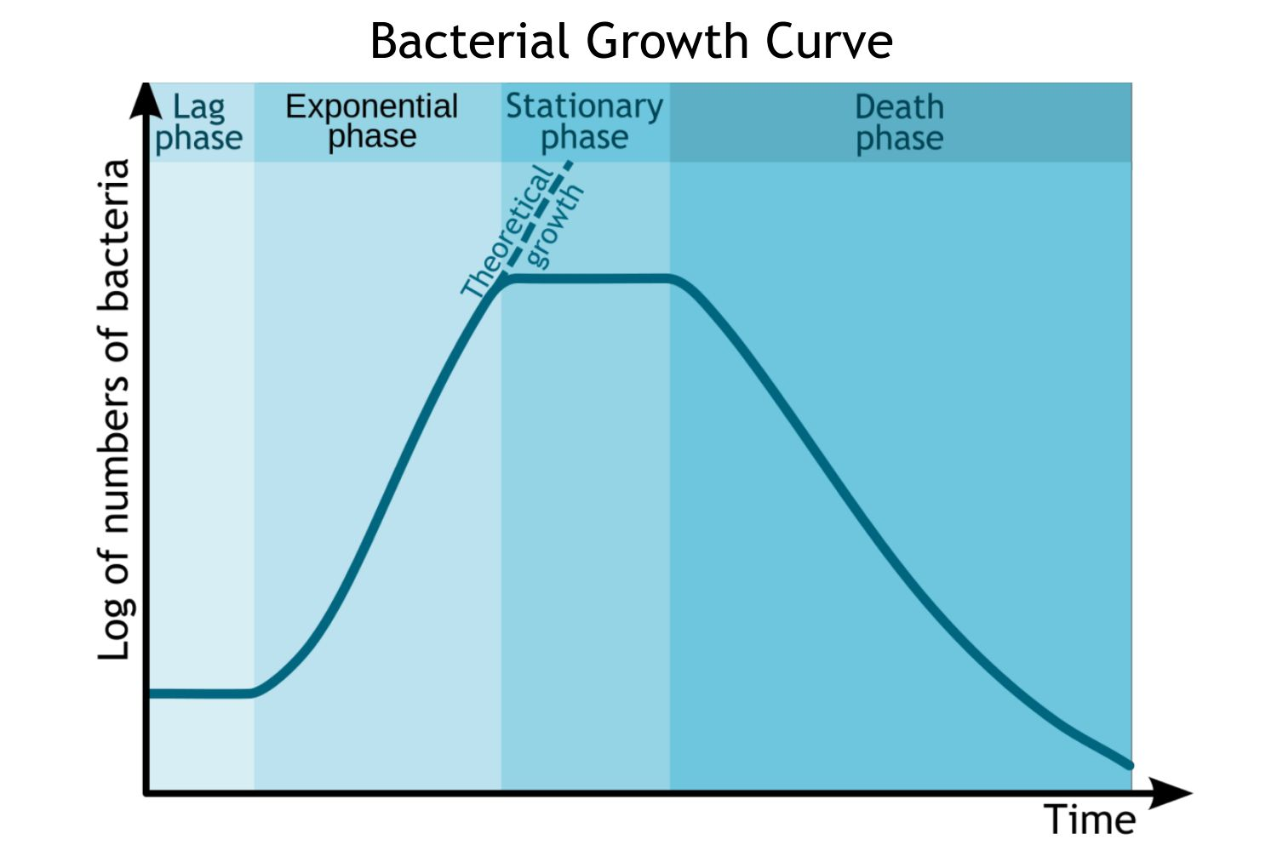

**1.5 Viruses and Subviral Particles**

Viral Structure

* Consists of a capsid (protein coat), which contains genetic material
* Sometimes consists of an envelope
  1. Envelope sensitive to heat, detergent, desiccation → easier to kill
  2. No envelope → more resistant to sterilization
* Cannot reproduce independently → must express and replicate genetic information within a host cell because they **lack ribosomes** to make proteins → **obligate intracellular parasites**
* Bacteriophage
  1. Has a tail sheath (acts like a syringe to inject genetic info)
  2. Has tail fibers (recognize and connect to the correct host cell)

Viral Genomes

* May be circular or linear, single- or double-stranded, DNA or RNA
* Single-stranded RNA
  1. **Positive** sense: directly translated to proteins
  2. **Negative** sense: this virus must carry an RNA replicase to synthesize the complementary strand, which acts as a template
* Retroviruses: enveloped, single-stranded RNA e.g. **HIV**
  1. Carry reverse transcriptase: RNA → DNA
  2. DNA then integrates into host cell genome → replication + transcription

Viral Life Cycle

* Infection (entry depends on type of virus) → Translation and Progeny Assembly (mode depends type of genetic material) → Progeny Release (cell death, large number of virions, or extrusion to keep the host cell alive)
* **Lytic or lysogenic**

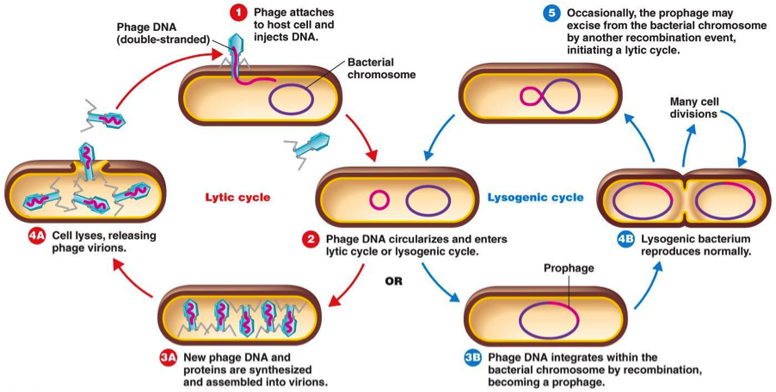

Prions

* **Infectious proteins**, non-living
* Misfolding of other proteins (α-helical structure → β-pleated sheet) → reduces solubility of protein and makes it highly resistant to degradation → protein aggregates → function of cell is reduced

Viroids

* Small pathogens, consisting of a very short circular **ssRNA that infects plants**
* Gene silencing